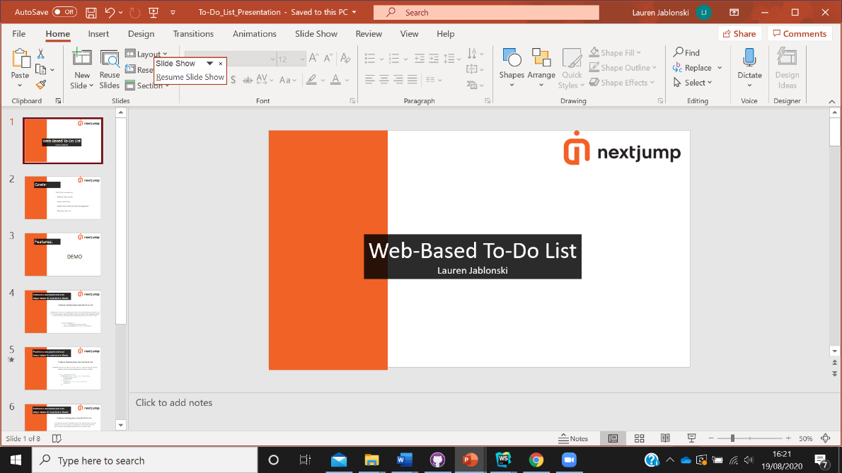Morning everyone. My names Lauren and I’m one of the new starters that will be joining your team next month. I am currently in a mentor programme with Jessie and Christa whom have been helping me to build a web-based to do list to help improve my knowledge of API’s and develop my skills in JavaScript, HTML and CSS.

The first task was to create a web-based To-Do list, which should have the functionality of a to do list using the provided API. Where the design and more advanced features of the to-do list where left open for exploration and interpretation.

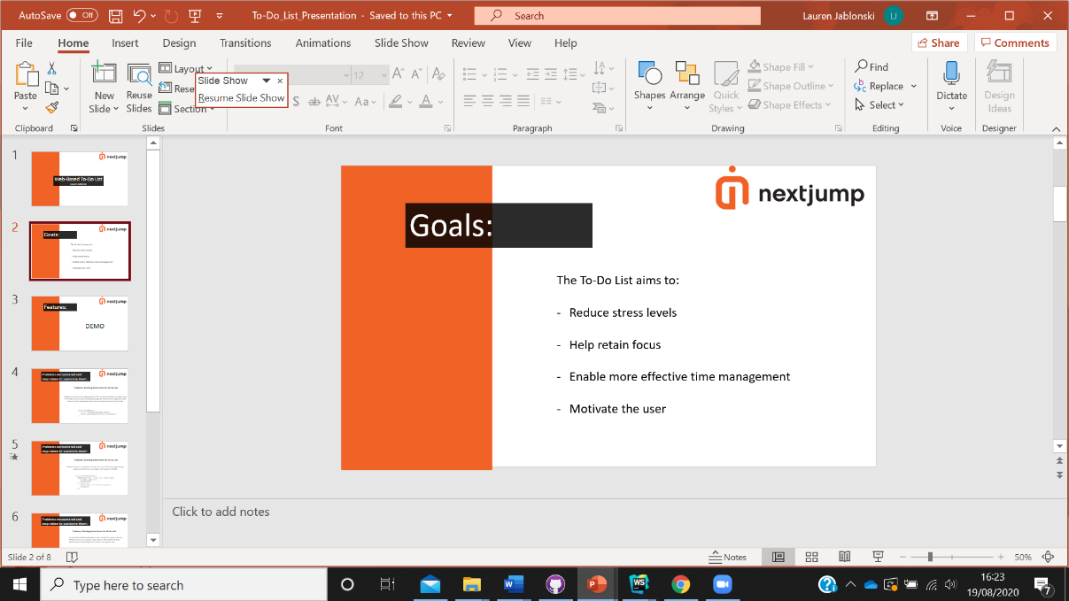The main goal that I wanted for this To-Do list was for it to reduce the stress levels of the user. I personally find it better for me to manage my stress when I have all the things I need to do in one place, as then it seems more manageable. If it seems more manageable then it helps me to stay focused and not get overwhelmed and lose time. This, in turn, makes my time management more effective as it enables me to prioritise tasks well. If my time management is good this enables me to complete items on my to do list quicker which helps me to stay motivated to complete other items in the To-Do list. Since just ticking or crossing one item off the to do list gives me a sense of progress and accomplishment which motivates me to complete more items in the list.

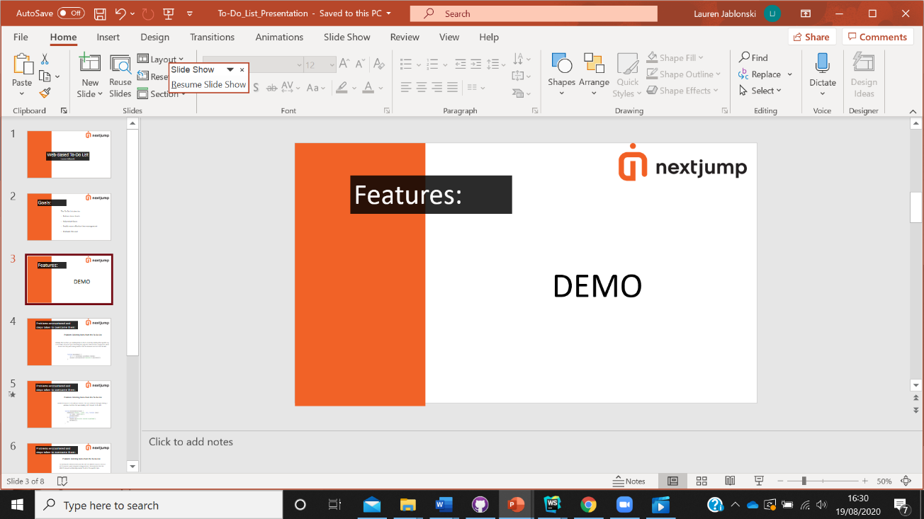All these features that I have found helpful in managing my time I have tried to encompass and work into the To-Do List, and I’ll now do a demo to show them to you now.

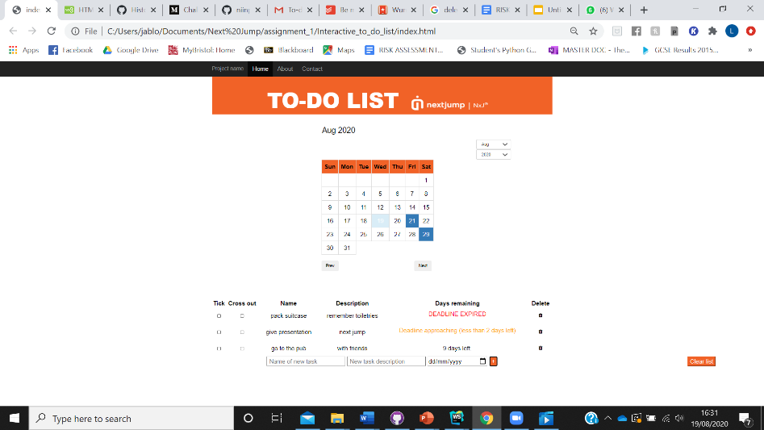

features to talk about and justify:

* calendar- to make it easier for the individual to visually see how many days they have left on the calendar. this might be more useful than the physical number of days for some people. i have included both the written number of days as well as a visual indication of how many days you have left since i want this to do list to be adaptive to its audience
* next and prev buttons-these buttons allow you to change the month you are looking at, by default the list will set to the month and year you are currently in.
* you can use the short cut in the top right hand corner -to skip to a particular year, this shortcut makes the user experience quicker and easier
* show you can add items to the list- when the items are added the form is cleared and the page is refreshed with the new to do list items on the page
* and show the 3 different things for the days remaining -added this to allow the user to balance their time better and to see those items that need to be prioritised first.
* also show that you can’t not enter anything for say the due date without an alert coming up-this feature helps you stay organised and ensures you don’t forget any deadline. so if you happened to forget to add the deadline it would prompt you to add one.
* show you can cross items off the list- say that when you click the button you get a tick button as well as a cross through the item on the to do list. personally i found it more satisfying to cross through an item on the to do list, whereas i know some people prefer to have a tick at the side so this way it caters for all preferences
* show you can delete items- alternatively to crossing out the item in the list you can just delete the item all together, you can also do this if you happen to make a mistake in the item too.
* show you can clear the entire list- when you have completed the list or just want to start again with your to do list you can just clear the entire list in one button

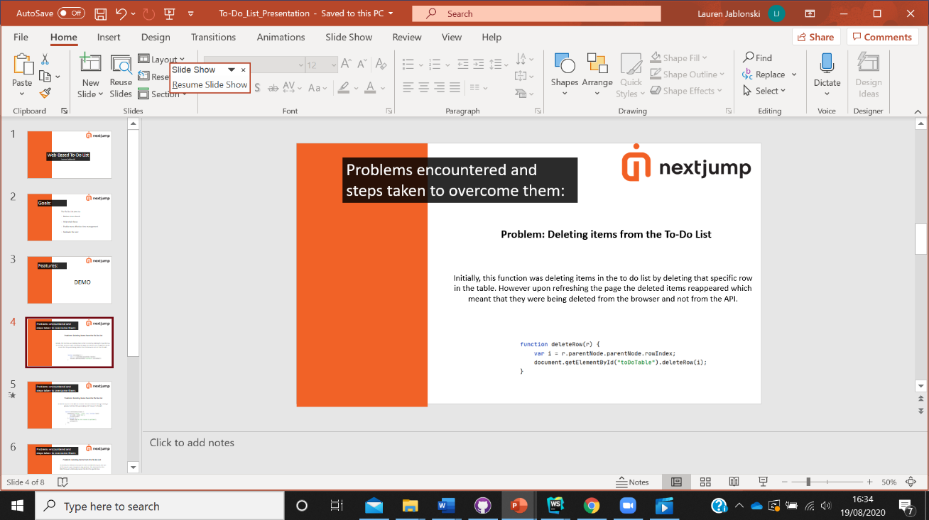I encountered a few issues when building this To-Do list. The largest problem came when trying to delete items from the to do list. Initially I wrote this function at the bottom, where it was deleting items in the to do list by deleting rows in the table. However, when the page was refreshed the items came back which meant that the items were being deleted from the browser and not the API.

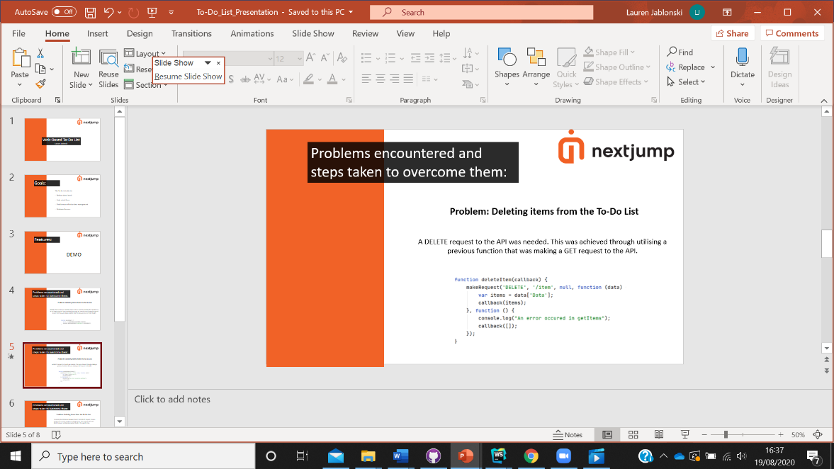

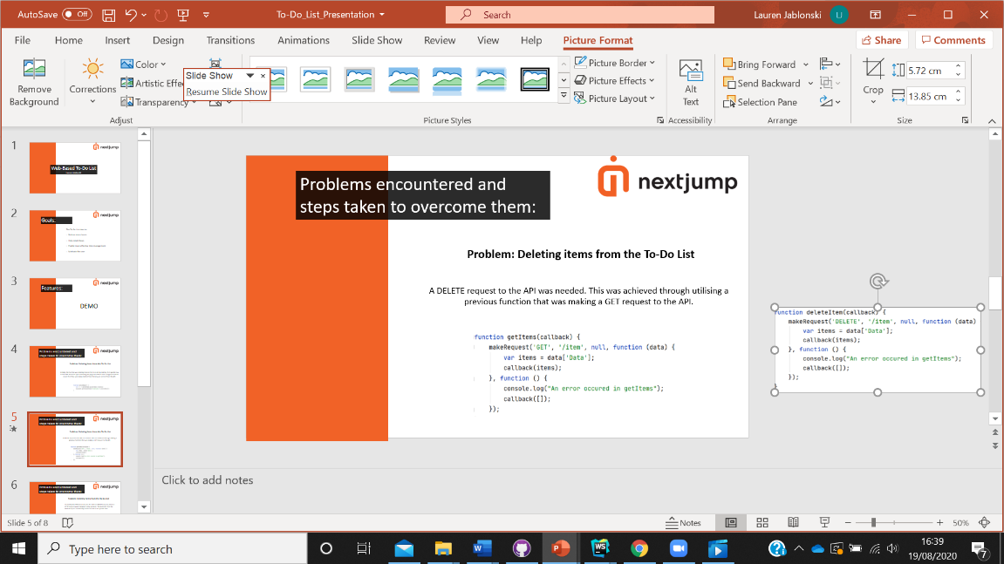Therefore it was clear that I needed to make a DELETE request to the API. And so I made use of this function I already had which was making a GET request to the API.

I assumed that GET and DELETE requests worked in the same way and so used the same format. However, this did not work and the console was returning a 400 status error which indicated that something was wrong in the way the request was being written.

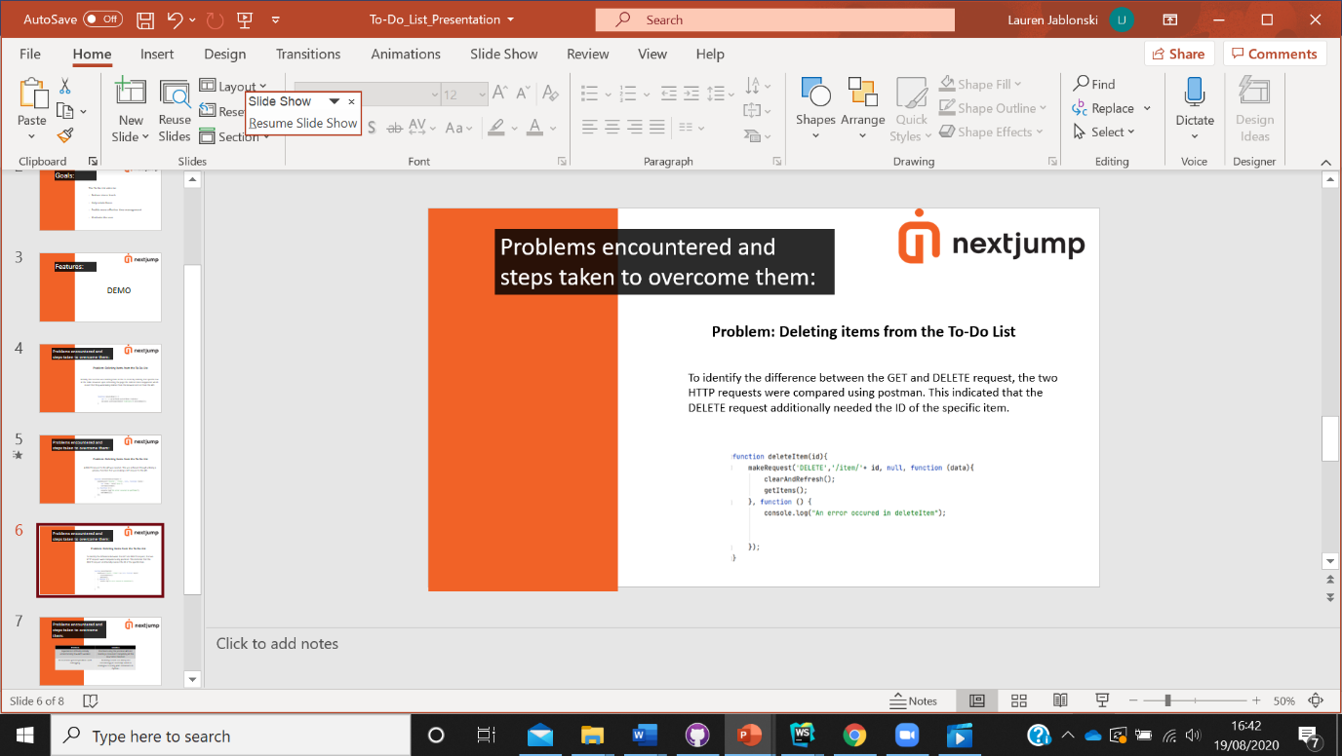In order to identify, the differences between the DELETE and GET requests I used postman to compare the two HTTP requests where this indicated that I needed to add the ID of the specific item in order to have a successful DELETE request to the API. Which actually makes a lot of sense now because otherwise how does the code know which item I want to delete.

Thus allowing me to arrive at a correctly working function.

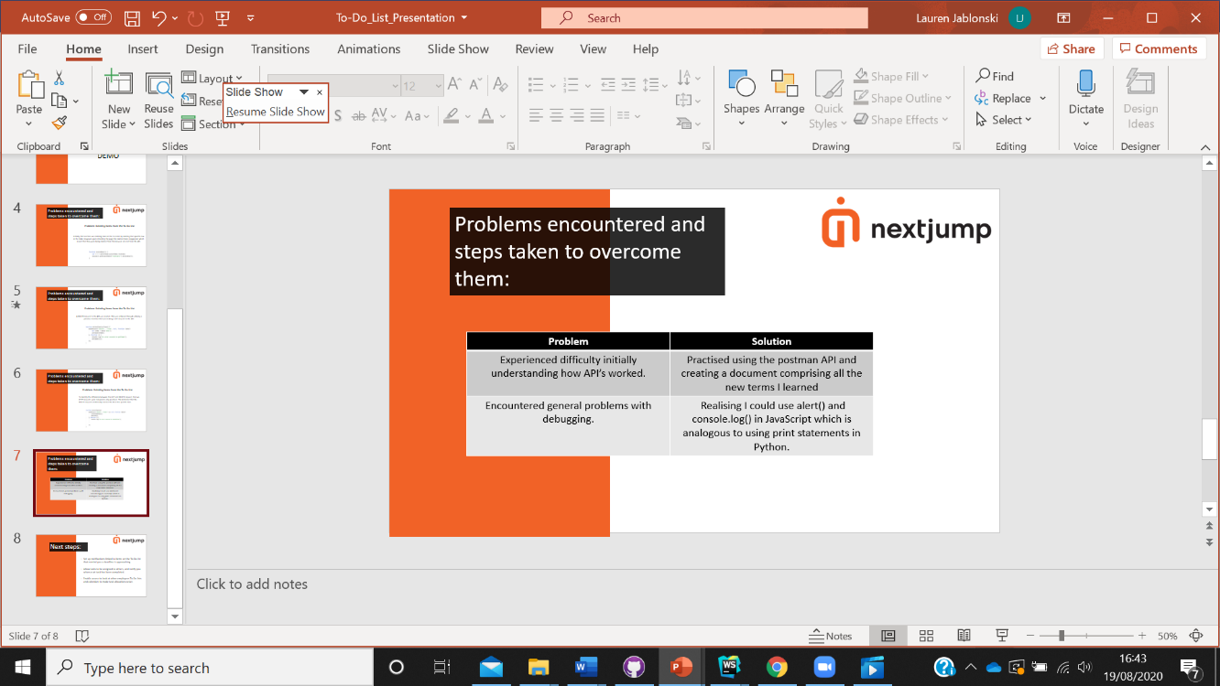

Some other generic problems I encountered were that I struggled to get my head round how API’s were working and so I practise using the postman API and watching their YouTube videos, as well as making a large document with all of the terms and key techniques I learned.

Finally, I found it difficult to debug at first and find which line of code was stopping the code from running. I then found that I could use alert() and console.log which are analogous to how I used print statements to debug in Python. I found this really useful to find something in JavaScript that was analogous to something else in Python, since I’m a lot more familiar with Python, has enabled me to understand JavaScript and get used to it a lot more.

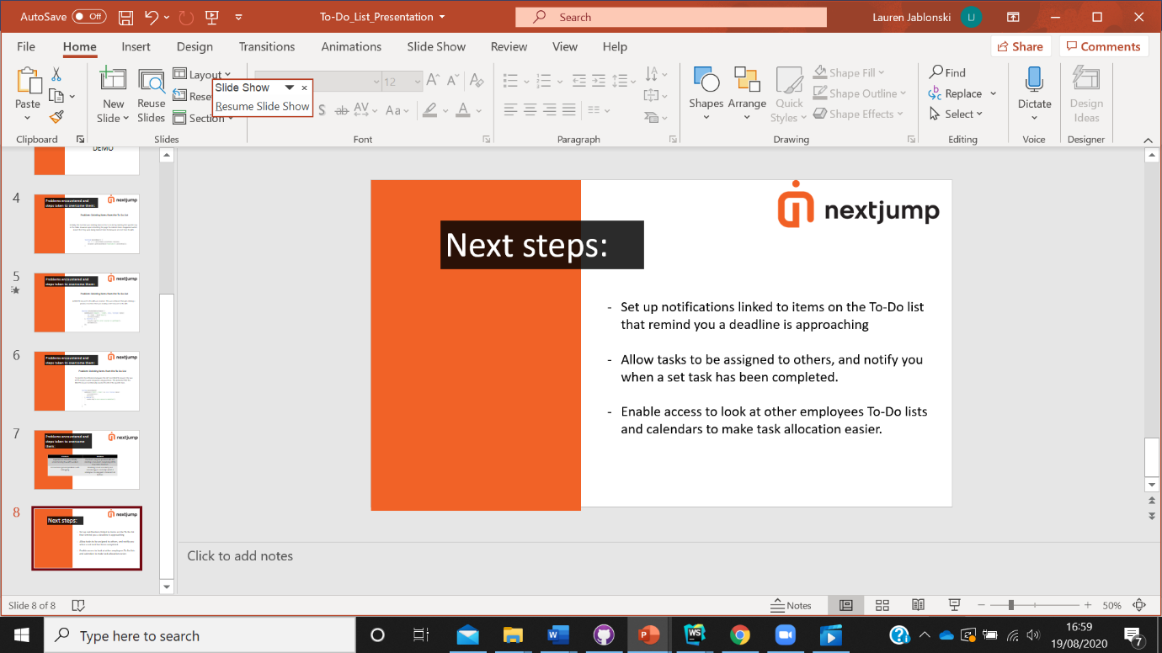The next steps I hope to take in building this to-do list is to set up notifications linked to each item on the to do list so that even when you’re not physically on the to do list you can get reminders that remind you of an approaching deadline.

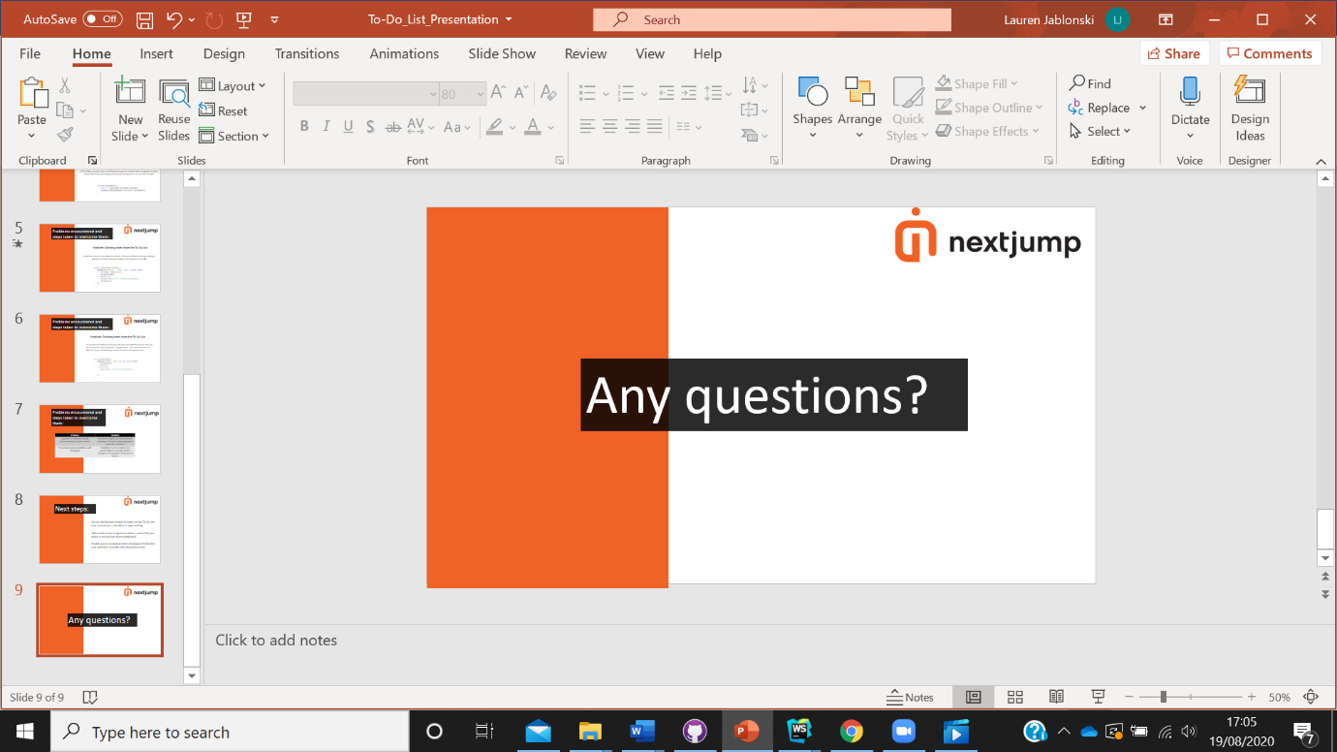Additionally, I would like in this to do list to be able to assign tasks to members of your team or family etc, where would then get notified when they have completed a particular task.

The assignment of these tasks would be made easier if you have access to everyones calendar so that you can see all their deadlines to see who might be more appropriate for a certain task based on workload and schedule.

Lots of this is completely new to me, and it's been a steep learning curve. I’d like to say thanks to Jessie and Christa for answering all my questions. Any questions?